EXERCISE 1: MAPPING THE HOMEGUARD ECOSYSTEM (30 MINUTES)
Goal: Create a Level 1 Data Flow Diagram (DFD) that illustrates how security data and user commands move through the HomeGuard system.
System Overview
HomeGuard is an integrated smart-home security solution designed to give homeowners peace of mind through remote monitoring and physical access control. The primary goal of the system is to synchronize physical security hardware with a digital interface, ensuring that only authorized users can modify the home's security state.
The Narrative
When a Homeowner interacts with the system, they provide an Authentication Request or an Access Code / PIN to the Manage Access & Authentication process. This process verifies the user’s identity by checking the User Registry for valid credentials. Once validated, a Validation Result is passed to the Control Devices process, which then issues an Actuation Signal (Lock/Unlock) to the Physical System. Any significant action here is recorded as events in the User Events data store.
The Physical System (sensors and hardware) constantly monitors the environment and sends Sensor Telemetry back into the system. The Monitor Threats process receives this telemetry and compares it against the current device state retrieved from the Device Db. If the system detects a breach or a specific condition, it generates a Push Notification sent directly to the Homeowner and logs the incident in the Event & Video Logs.
Simultaneously, the Physical System provides an Encrypted Video Feed from its cameras. This feed is handled by the Process Video Stream logic, which ensures the footage is accessible for live viewing and is properly archived in the Event & Video Logs for later review.

Your Task
Based on the description above, identify the following and represent them in a DFD:
- External Entities: Who or what sits outside the system boundary?
- Processes: What are the main "actions" happening (e.g., Managing Access, Processing Alerts)?
- Data Stores: Where does the system need to "remember" information (e.g., Device States, Access Logs)?
- Data Flows: How does information travel between the entities and the processes?
- Boundaries: where are the limits that separate the system through the external entities.

EXERCISE 2: Easy — DOM Injection Prevention
GitHub: https://github.com/kabartsjc/GMU-CYSE411.git

Scenario: The "Secure Status Portal" has a feature to display system notifications to users. The current implementation takes an array of strings (notifications) and renders them in an unordered list (<ul>). An attacker discovered they can send a notification containing HTML tags to execute scripts in other users' browsers.
Vulnerable Code:
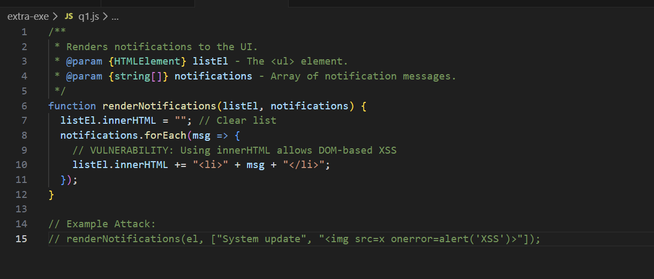

Task: Refactor the renderNotifications function to prevent DOM injection. Ensure that notification messages are treated strictly as text, not as HTML.
Solution Hint: Instead of concatenating strings into innerHTML, use document.createElement('li') and assign the message to the textContent property.
Course Reference: Unit 1.3 (Slides 2, 4 and 60)

EXERCISE 3: Medium — Input Sanitization & Logic
Scenario: Users can choose a display name for their profile. To prevent database issues and UI breaking, the system must sanitize the username. The requirements are: only letters, digits, underscores, and dashes are allowed; any other character must be replaced by an underscore; and the name cannot exceed 20 characters.
Vulnerable Code:
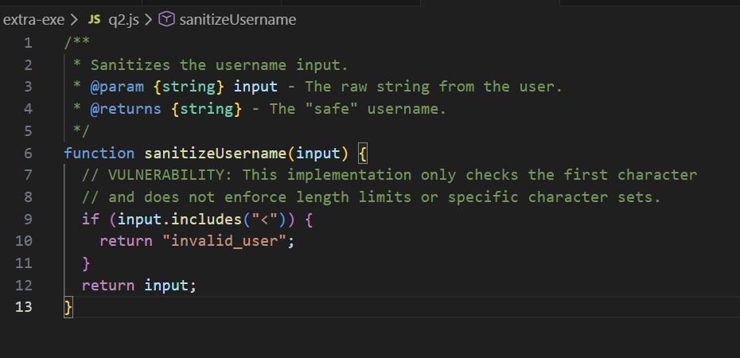
Task: Complete the sanitizeUsername function. Use a Regular Expression (Regex) to replace all "illegal" characters with an underscore _ and ensure the final string is truncated to a maximum of 20 characters.
Required Logic:
- Use .replace() with regex.
- Use .substring(0, 20) to limit length.

Tips:
- https://docs.icewarp.com/Content/IceWarp-Server/Administration-Nodes/Domains%20&%20Accounts/Simple%20RegEx%20Tutorial.htm
- https://www.rexegg.com/regex-quickstart.php
- https://regex101.com/
Course Reference: app.js (Part A — Safe DOM utilities).Your app.js file contains a detailed comment section for sanitizeUsername(input) with specific rules:
- Allow only letters, digits, underscores, and dashes.
- Convert others to _.
- Limit to 20 characters.

EXERCISE 4: Hard— Secure Async Fetch & Error Handling
Scenario: The application fetches user profile data from a remote server using the fetch API. In JavaScript, fetch only throws an error if there is a network failure; it does not reject the promise on HTTP errors like 404 (Not Found) or 500 (Server Error). The current code fails to check the response status, leading to a state where the application might process an empty or "undefined" profile as if it were valid.
Vulnerable Code:
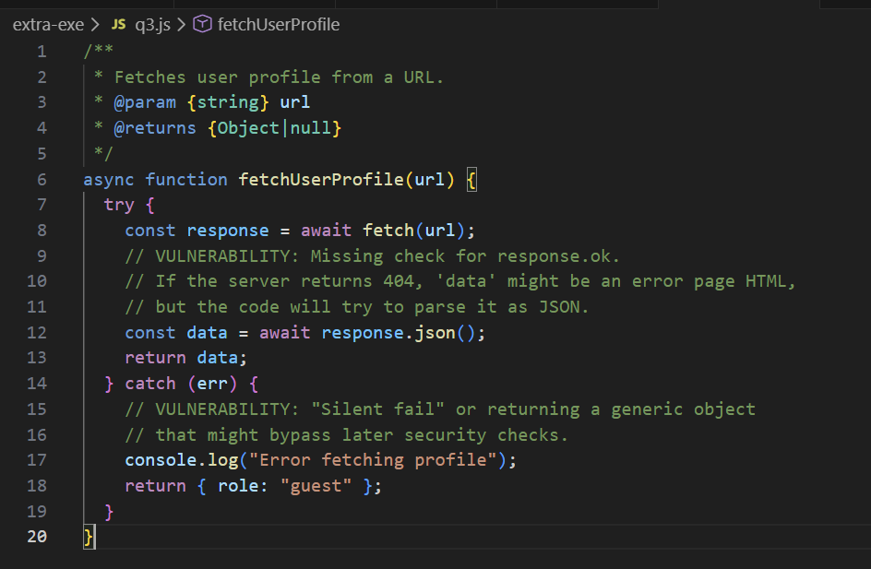

Task: Secure the fetchUserProfile function. Your implementation must:
- Properly await the fetch call.
- Check if the response was successful using response.ok. If not, throw an error or return null.
- Wrap the JSON parsing in a way that handles malformed JSON without crashing the app.
- Ensure the function returns null if any part of the process fails, preventing the "default-to-guest" logic inside the fetcher itself.

Course Reference: Unit 1.3 (Slides 1 and 44) and Unit 1.2 (Slide 8).
- Context: Unit 1.3 covers "Asynchronous execution using promises and async/await" and "Using fetch() for basic client–server communication." Unit 1.2 covers HTTP status codes (200 OK vs 404 Not Found).

